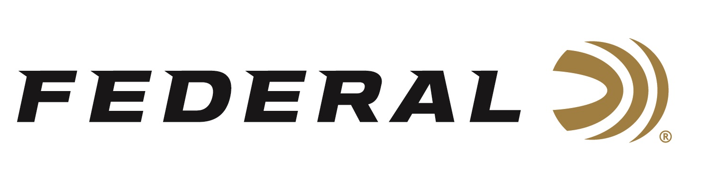

FOR IMMEDIATE RELEASE

Federal Ammunition Partners with Red Arrow

ANOKA, Minnesota – April 13, 2020 – Federal Ammunition announces a new partnership with popular television host Kip Campbell and his series “Red Arrow.” Federal will become the official ammunition of the award-winning multi-network series when Season 12 of the show launches in July.

“Federal is excited to join forces with Kip Campbell and his Red Arrow TV team,” says Brian Kelvington, Federal Ammunition’s Media Director. “Kip and crew produce cutting edge content that is engaging and captures the fun of hunting and shooting,” says Kelvington. Red Arrow put Federal Ammunition’s Premium® centerfire line of ammunition to the test last fall on whitetails used Heavyweight TSS on gobblers in his home state of Virginia this spring. Followers of the program will get to witness the fantastic results in an entertaining format.

“This is a great partnership for Red Arrow,” says Kip Campbell. “We know bow hunters shoot firearms and traditional firearms hunters enjoy bow hunting, so this partnership validates our messaging vehicle for both groups of hunting enthusiasts,” says Campbell.

Campbell and Red Arrow team released a video announcing the new partnership and can be viewed here: https://www.facebook.com/RedArrowTV/videos/1650027891828735/

Fans of the show can expect Federal brand and product integration into the edgy and fun programming on Monday nights in early July. Check local listings for dates and airtimes. In the meantime, follow along with Red Arrow’s spring and summer hunts on Facebook [@RedArrowTV], Instagram [@red_arrow_tv], and YouTube [@RedArrow].

Federal ammunition can be found at dealers nationwide or purchased online direct from Federal. For more information on all products from Federal or to shop online, visit www.federalpremium.com.

Press Release Contact: JJ Reich
Senior Manager – Press Relations
E-mail: VistaPressroom@VistaOutdoor.com

About Federal Ammunition
Federal, headquartered in Anoka, MN, is a brand of Vista Outdoor Inc., an outdoor sports and recreation company. From humble beginnings nestled among the lakes and woods of Minnesota, Federal Ammunition has evolved into one of the world's largest producers of sporting ammunition. Beginning in 1922, founding president, Charles L. Horn, paved the way for our success. Today, Federal carries on Horn's vision for quality products and service with the next generation of outdoorsmen and women. We maintain our position as experts in the science of ammunition production. Every day we manufacture products to enhance our customers' shooting experience while partnering with the conservation organizations that protect and support our outdoor heritage. We offer thousands of options in our Federal Premium and Federal® lines-it's what makes us the most complete ammunition company in the business and provides our customers with a choice no matter their pursuit.

